**FOR IMMEDIATE RELEASE**

**Media Contact: Teresa Campbell**

**800-788-2040 | TeresaC@piamidam.org**

**Rebranding a Benchmark Study: The Wage + Benefits Survey Sharpens Its Identity to Lead with Clarity**

**[June 5, 2025 – Dallas, TX ]** — With bold new branding and a platform built for clarity, the Wage + Benefits Survey is making a powerful statement: when it comes to labor data in the printing industry, trust matters. And so does recognition.

The Wage + Benefits Survey has long been the industry's gold standard. Now in its 50th+ year, the survey is conducted annually by America’s Printing Association Network (APAN) and administered by PIA MidAmerica. It reflects the input of over 400 firms and more than 15,000 employees across North America. The result is the most comprehensive view available into wages, benefits, and workforce policies specific to the graphic communications industry.

This year’s new logo and identity system are designed to reflect the trustworthiness and modernity of the tool itself. But the rebrand also responds to a real and growing need: clarity in a crowded and sometimes confusing marketplace.

"We’ve had members tell us, ‘I already did that survey,’ when in fact, they had confused it with another," said Teresa Campbell, president of PIA MidAmerica and program director. “That’s a problem we felt responsible to fix — not by getting louder, but by getting clearer.”

In recent years, competing compensation surveys have entered the market using similar language and even outreach strategies. And outside the industry, general tools like Salary.com and Indeed.com offer broad benchmarks that create false confidence but lack real relevance for specialized print industry roles. These platforms often rely on self-reporting or extrapolated approximations that miss the nuance of job-specific benchmarks across prepress, press, bindery, packaging, and more.

“They may be a starting point, but they’re not a decision-making tool for serious workforce planning,” Campbell added. “Our survey drills down to the actual jobs in our industry—and it’s built by and for people who understand it.”

Backed by a modern visual identity—featuring clean geometry and a distinct blue, yellow, and white palette—the new branding is both recognizable and purposeful. It clearly separates the Wage + Benefits Survey from imitators and helps companies immediately recognize the most credible source.

The brand refresh also coincides with major platform improvements made in recent years. The online portal and in-depth analysis tool now supports multi-location firms, allows returning users to auto-fill from prior data, and includes segmented results by region, company size and industry segment. Combined with a growing set of policy benchmarks—from PTO and overtime to insurance and retirement contributions—the survey offers a depth of insight unmatched by others in the space.

The 2025 Wage + Benefits Survey is currently open and accepting submissions. Participation is free for industry employers, for access to the survey or assistance in participating, visit [**portal.printindustries.org**](https://portal.printindustries.org) or contact your APAN representative. Questions may be directed to Teresa Campbell at 800-788-2040 or TeresaC@piamidam.org.

In a labor market where every decision counts, the Wage + Benefits Survey continues to offer what the industry needs most: trustworthy data, real relevance, and now, a brand identity that reflects its leadership.

Logo Images:

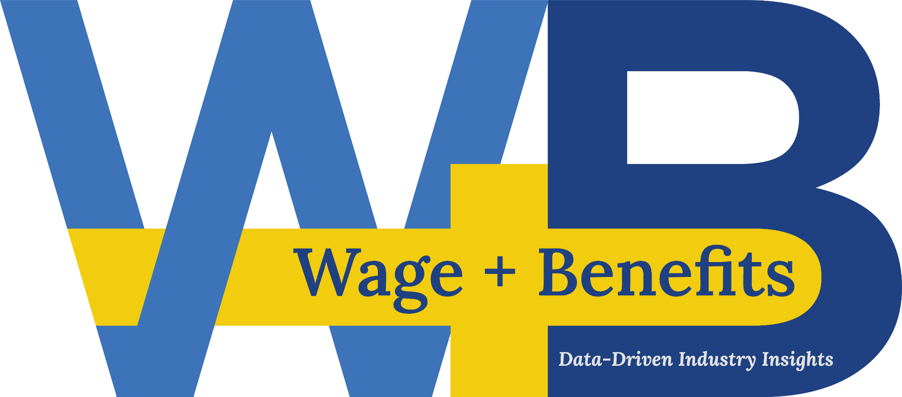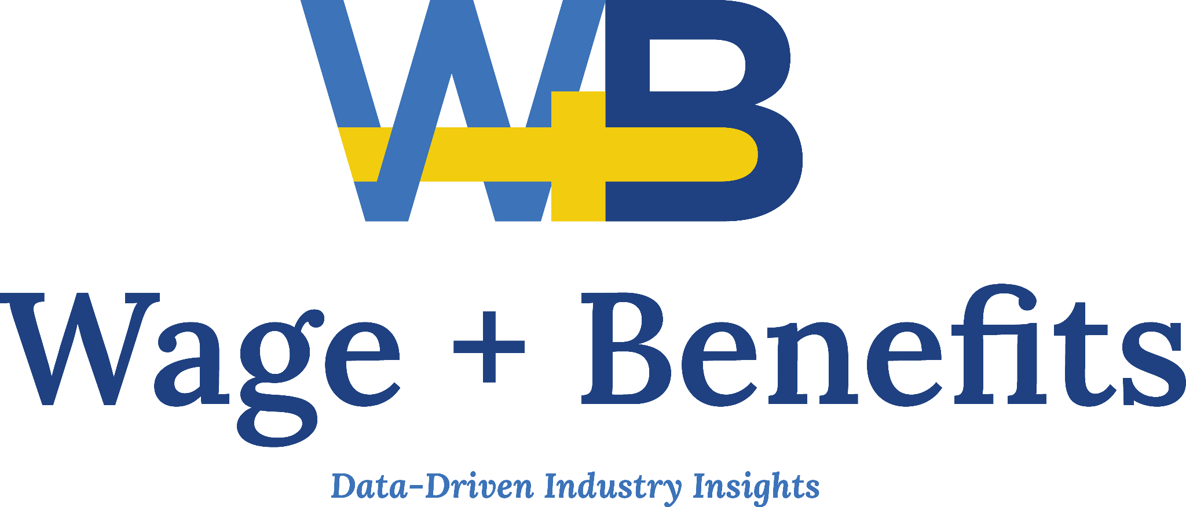

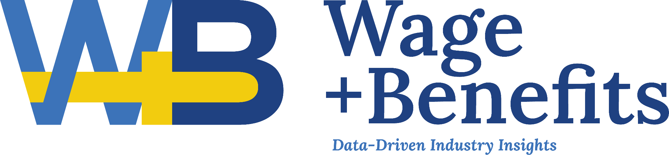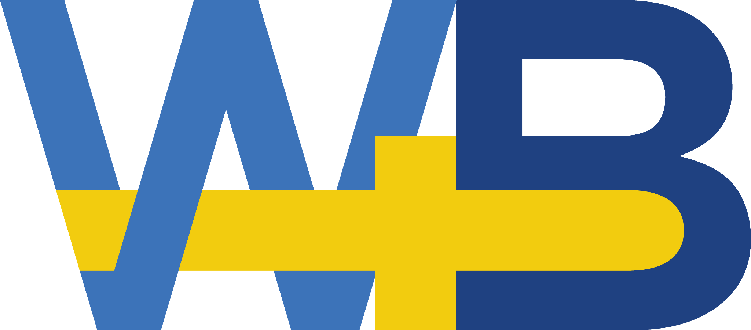

Accompanying Images on the Following Pages:

-MORE-

