FOR IMMEDIATE RELEASE
Media Contact: Teresa Campbell
800-788-2040 | TeresaC@piamidam.org
America’s Printing Association Network • Final Weeks to Participate in the 2026 Wage + Benefits Survey
Industry-wide compensation benchmarking initiative closes July 17
[July 8, 2026 – Dallas, TX] — The 2026 Wage + Benefits Survey, conducted by America’s Printing Association Network (APAN) and administered by PIA MidAmerica, will close Friday, July 17, giving print and packaging organizations across the country a final opportunity to participate in one of the industry’s most comprehensive compensation and workforce benchmarking initiatives.
The survey gathers industry-specific data related to wages, benefits, PTO policies, healthcare offerings, shift differentials, workforce trends, and compensation strategies across more than 200 positions within print and packaging operations.
As organizations continue navigating workforce shifts, evolving employee expectations, operational pressures, and long-term staffing challenges, participation helps strengthen the accuracy and value of benchmarking tools used throughout the industry.
“The strength of the survey is directly connected to participation,” said Teresa Campbell, program director and president of PIA MidAmerica. “The more organizations that contribute data, the more valuable and actionable the reporting becomes for companies trying to make informed workforce and compensation decisions.”
The survey platform allows participating organizations to benchmark by region, company size, and industry segment while evaluating trends related to compensation, benefits, and workforce planning.
Data gathered through the initiative also supports broader workforce development and industry advocacy efforts by helping demonstrate the long-term value and career opportunities available throughout the print and packaging industry.
The 2026 Wage + Benefits Survey is supported by Significans Automation, a company specializing in workflow automation, systems integration, and operational optimization for print and packaging organizations across North America.
Participation is free, and all submitted information remains confidential and securely aggregated for reporting purposes.
Organizations interested in participating should complete the survey prior to the July 17 closing date at portal.printindustries.org.
Questions regarding participation may be directed to Teresa Campbell at 800-788-2040 or TeresaC@piamidam.org.

Logo Images:
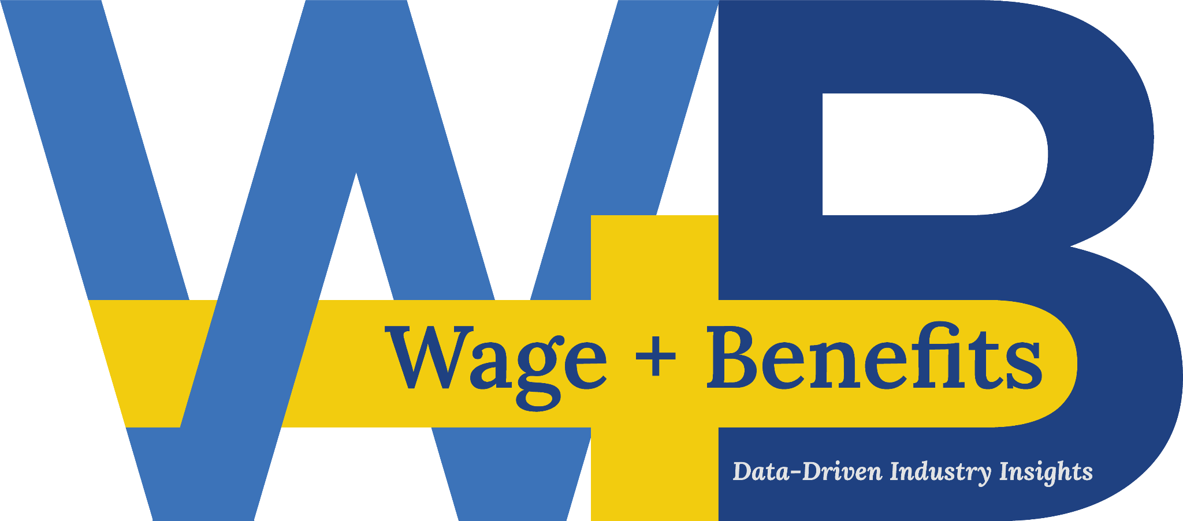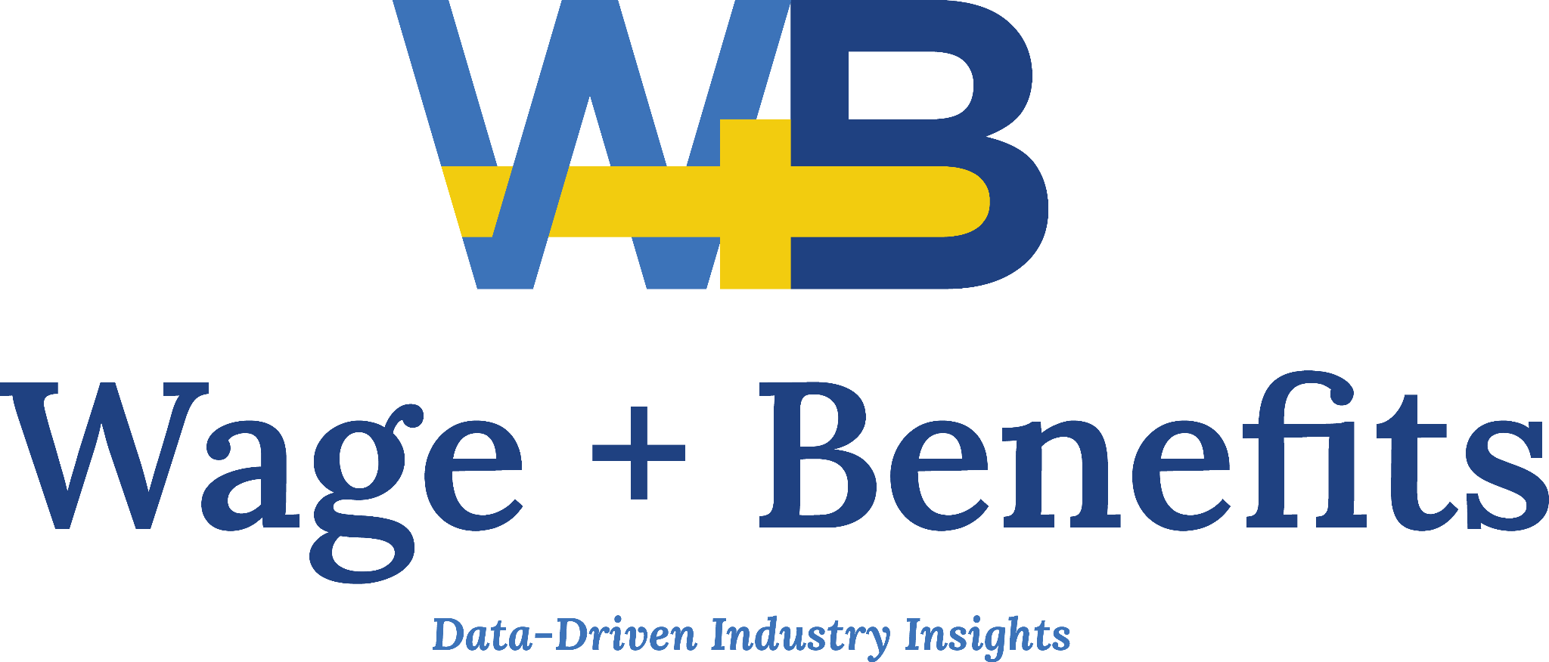


Accompanying Images on the Following Pages:
-MORE-
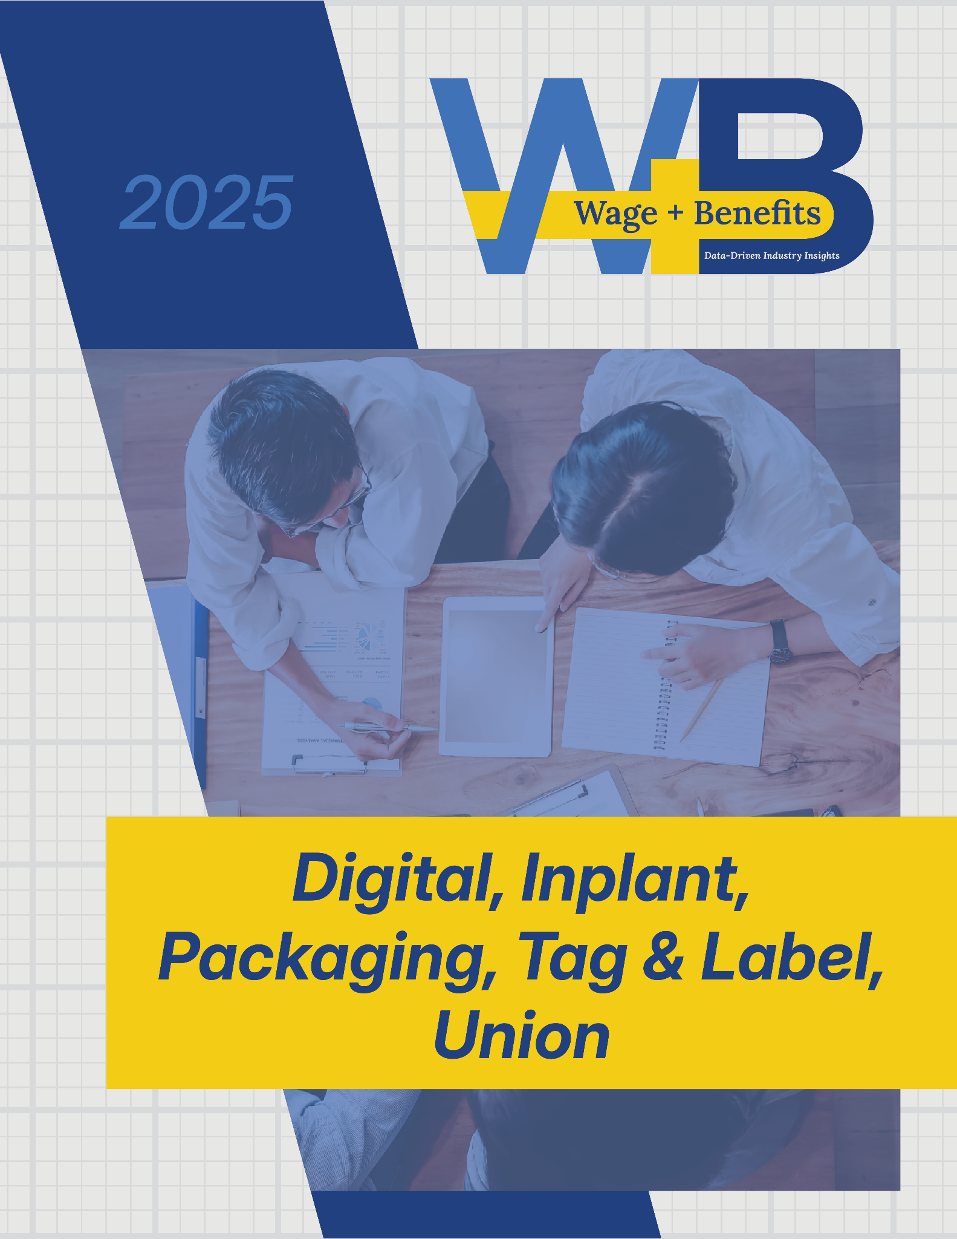
-MORE-
